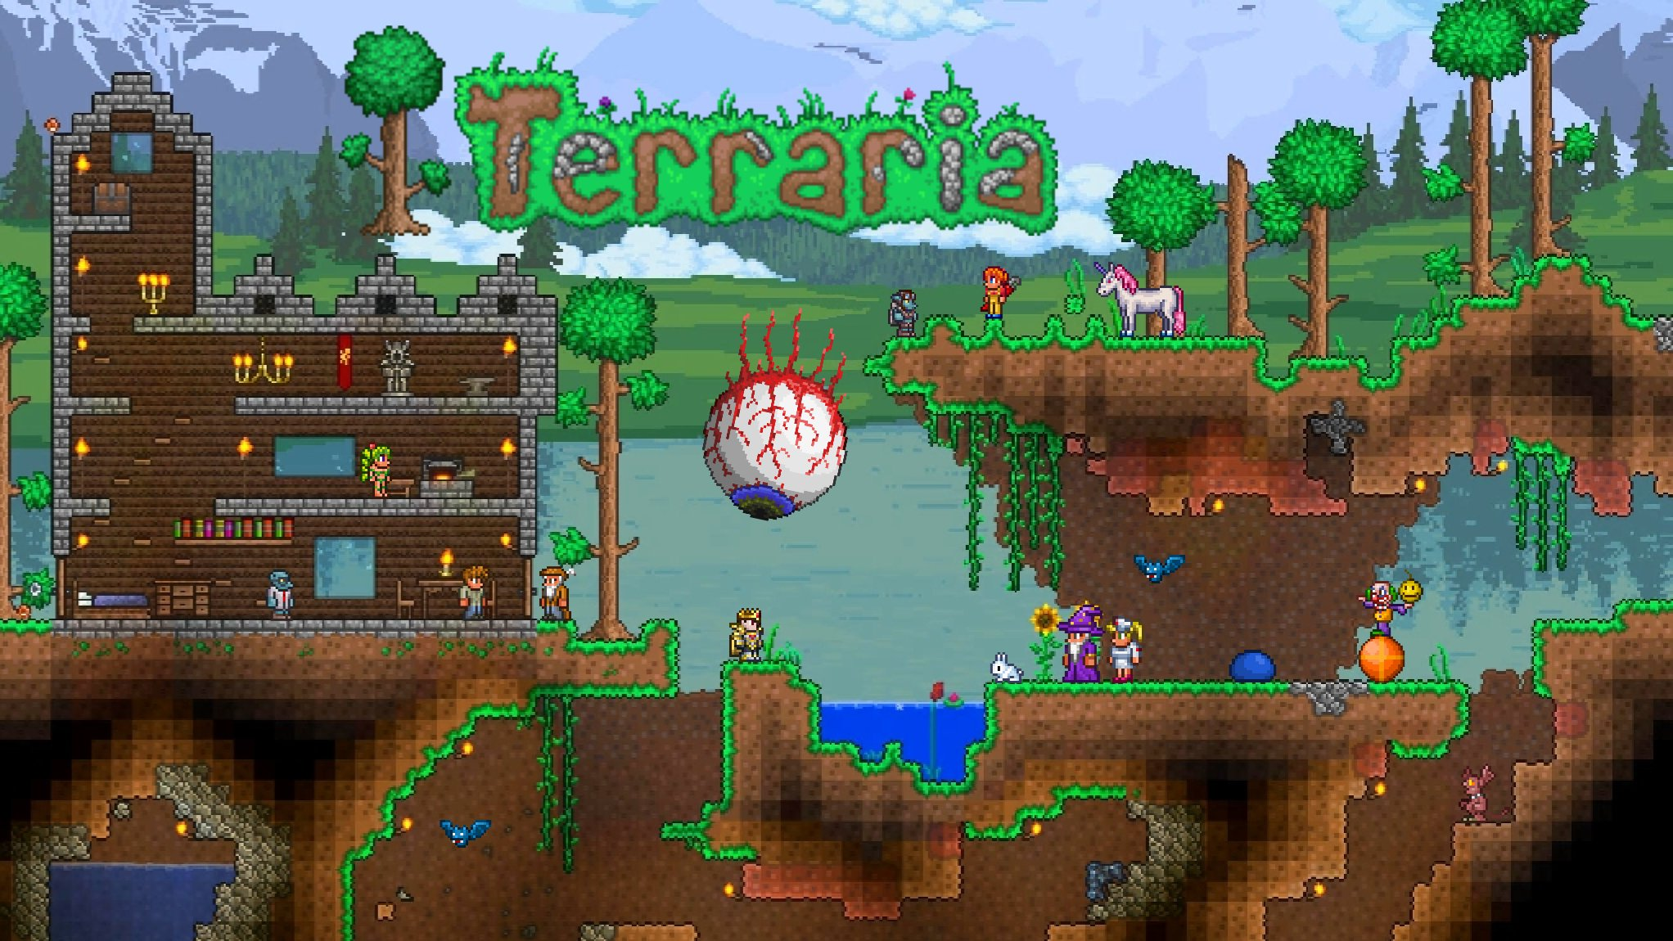
Looking at this image im going to recreate the eye and the tree into a 3d space. The reasoning for this is because ive made this game in 3d for a previous class and this give me a chance at redemption, if you wanted any context for why I picked it. The way I would recreate these in a 3D space I would use spheres for the eye and the tops of the trees and the leaves. I would also use cylinders for the tree body and the branches. And I would probably add a plane as a floor to show some depth and give something to compare against. I would also add some cylinders as the tendrils behind the eye. If I wanted to be extra and add some of the castle on the side I would add a few boxes as the main part with another longer box out the top and some prisims for the top decorations. To add some extra context during another 3d art class I made another terraria scene and when I thought it turned out good the teacher said that I maybe I wasn’t meant to do 3d art so I’m going to show them but that’s just some extra context. Thingking a little harder about this I could also use a plane as a background and to change the image I may add a moon in the background using a sphere or by adding it into the background plane.
So for a final list we have sphere for the eye, tree leaves, and possible moon. We have cylinder for tree trunk, tendrils, and branches. We have box for the castle and tower. We have prism for castle decorations. And finally we have planes for the background and floor.

